CSA0604-DAA

Session 2 Lab Experinments

Name : K.Nagapreetham
Reg.No: 192525242

1.Write a program that takes an input list of n numbers and creates a new list containing
only the unique elements from the original list. What is the space complexity of the
algorithm?
Code:
#include <stdio.h>

int main() {
int arr[100], unique[100];
int n, i, j, k = 0, found;

printf("Enter number of elements: ");
scanf("%d", &n);

printf("Enter elements:\n");
for (i = 0; i < n; i++)
scanf("%d", &arr[i]);

for (i = 0; i < n; i++) {
found = 0;

for (j = 0; j < k; j++) {
if (arr[i] == unique[j]) {
found = 1;
break;
}
}

if (!found) {
unique[k] = arr[i];
k++;
}
}

printf("Array with unique elements:\n");
for (i = 0; i < k; i++)
printf("%d ", unique[i]);

return 0;
}
OUTPUT:

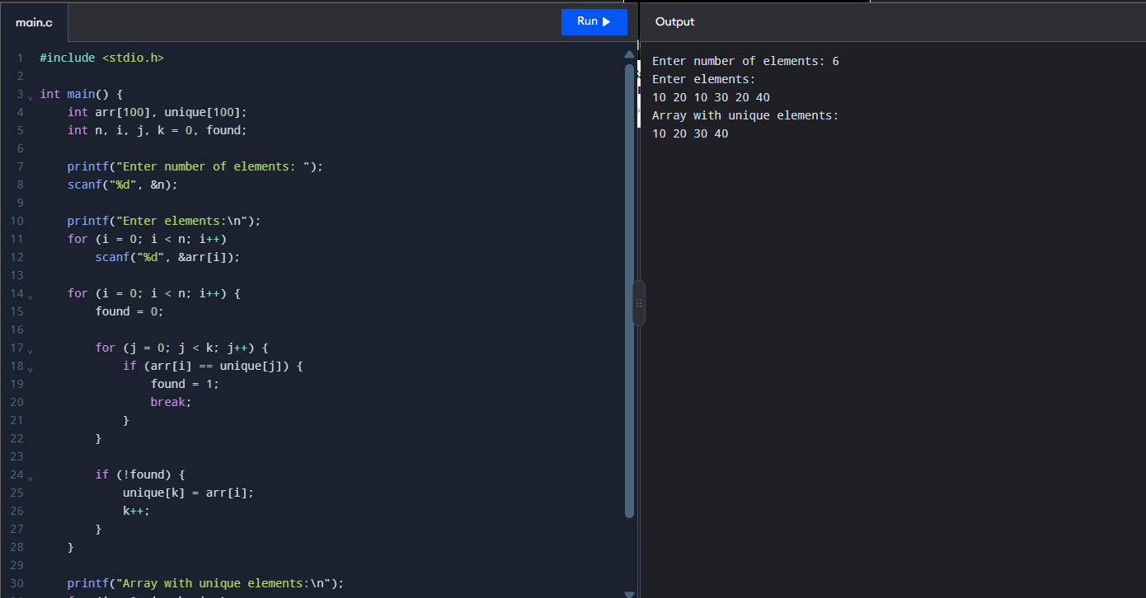

2. Sort an array of integers using the bubble sort technique. Analyze its time complexity
using Big-O notation. Write the code

CODE:
#include <stdio.h>

int main() {
int arr[100], n, i, j, temp;

printf("Enter number of elements: ");
scanf("%d", &n);

printf("Enter elements:\n");
for (i = 0; i < n; i++)
scanf("%d", &arr[i]);

for (i = 0; i < n - 1; i++) {
for (j = 0; j < n - i - 1; j++) {
if (arr[j] > arr[j + 1]) {
temp = arr[j];
arr[j] = arr[j + 1];
arr[j + 1] = temp;
}
}
}

printf("Sorted array:\n");
for (i = 0; i < n; i++)
printf("%d ", arr[i]);

return 0;
}

OUTPUT:
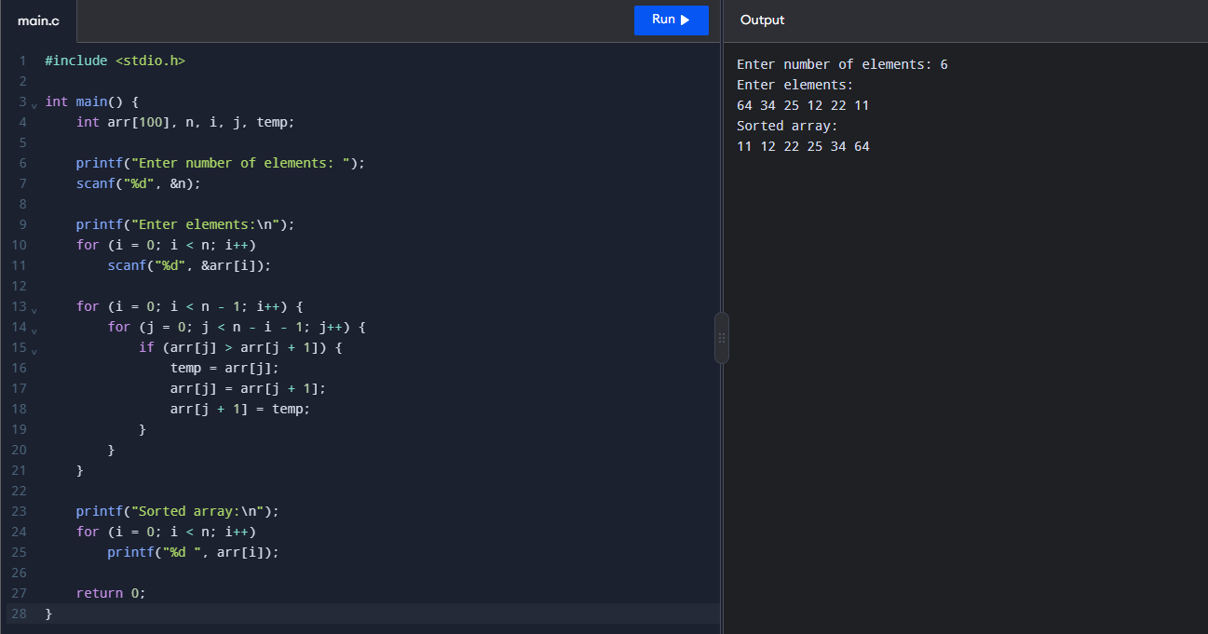

3. Checks if a given number x exists in a sorted array arr using binary search. Analyze its
time complexity using Big-O notation.
CODE:
#include <stdio.h>

int main() {
int arr[100], n, i;
int key, low, high, mid;
int found = 0;

printf("Enter number of elements: ");
scanf("%d", &n);

printf("Enter elements in sorted order:\n");

for (i = 0; i < n; i++)
scanf("%d", &arr[i]);

printf("Enter element to search: ");
scanf("%d", &key);

low = 0;
high = n - 1;

while (low <= high) {
mid = (low + high) / 2;

if (arr[mid] == key) {
found = 1;
break;
}
else if (arr[mid] < key) {
low = mid + 1;
}
else {
high = mid - 1;
}
}

if (found)
printf("%d exists in the array.\n", key);
else
printf("%d does not exist in the array.\n", key);

return 0;
}

OUTPUT:
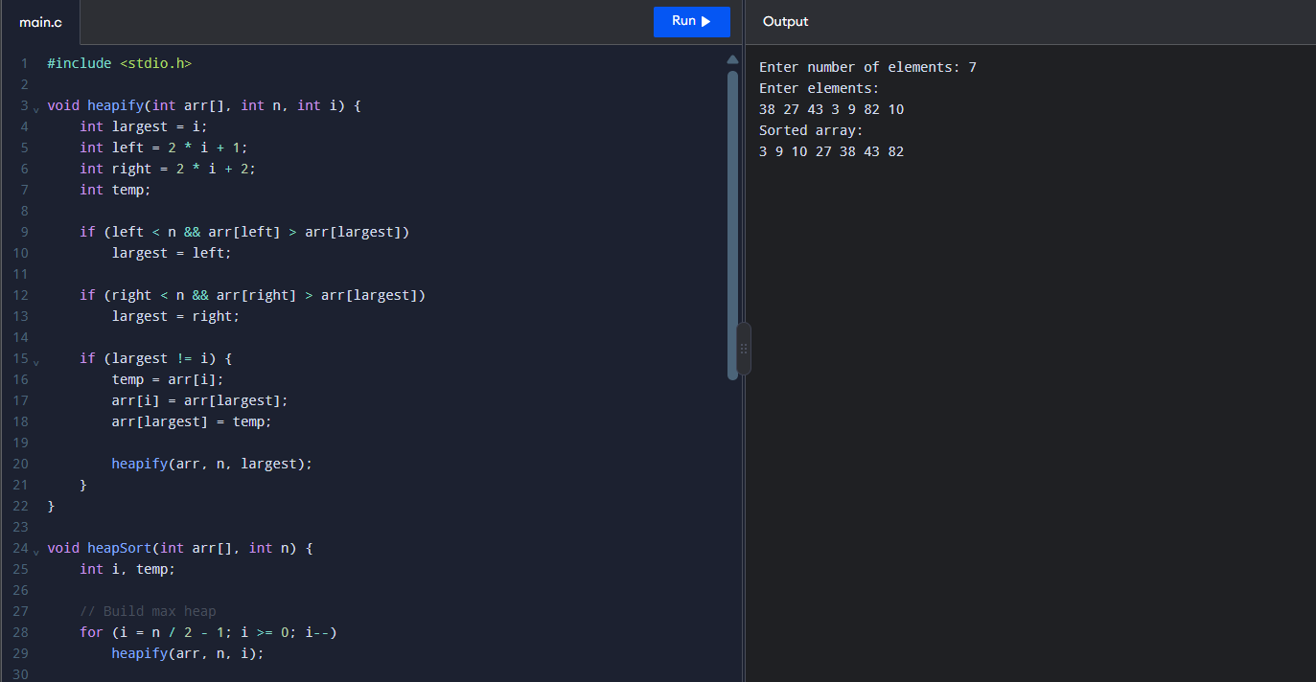

4. Given an array of integers nums, sort the array in ascending order and return it. You
must solve the problem without using any built-in functions in O(nlog(n)) time complexity and with the smallest space complexity possible.

CODE:
#include <stdio.h>

void heapify(int arr[], int n, int i) {
int largest = i;
int left = 2 * i + 1;
int right = 2 * i + 2;
int temp;

if (left < n && arr[left] > arr[largest])
largest = left;

if (right < n && arr[right] > arr[largest])
largest = right;

if (largest != i) {
temp = arr[i];
arr[i] = arr[largest];
arr[largest] = temp;

heapify(arr, n, largest);
}
}

void heapSort(int arr[], int n) {
int i, temp;

// Build max heap
for (i = n / 2 - 1; i >= 0; i--)
heapify(arr, n, i);

// Extract elements from heap
for (i = n - 1; i > 0; i--) {
temp = arr[0];
arr[0] = arr[i];
arr[i] = temp;

heapify(arr, i, 0);
}
}

int main() {
int arr[100], n, i;

printf("Enter number of elements: ");
scanf("%d", &n);

printf("Enter elements:\n");

for (i = 0; i < n; i++)
scanf("%d", &arr[i]);

heapSort(arr, n);

printf("Sorted array:\n");

for (i = 0; i < n; i++)
printf("%d ", arr[i]);

return 0;
}
OUTPUT:
